Since passage of the health care law in 2010 there have been significant changes in health insurance that have protected patients. Nationally, approximately 30 million Americans have gained health insurance coverage through the marketplaces, Medicaid expansion, and young adults being able to stay on their parents’ insurance plans., This fact sheet provides information on how changes to the health care market have directly affected the state of Ohio.
Health Insurance Expansion
State Spotlight – Ohio
Health Insurance Matters
Research by the American Cancer Society shows that uninsured Americans are less likely to get screened for cancer, more likely to have their cancer diagnosed at an advanced stage, and less likely to survive that diagnosis than their insured counterparts. Thus, having access to comprehensive health insurance coverage is particularly important for the 66,020 Ohioans who are expected to be diagnosed with cancer in 2016 and the estimated 536,430 Ohioans who are cancer survivors.
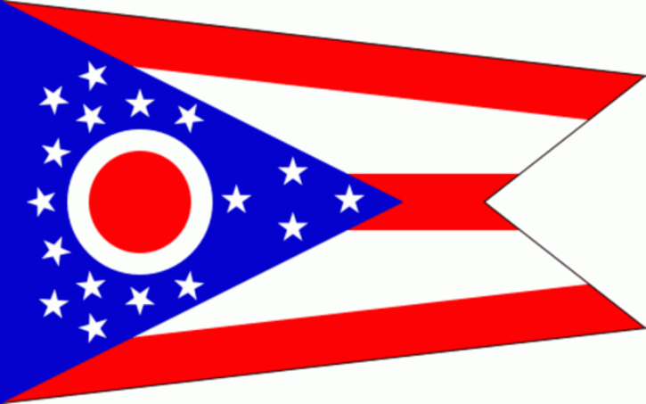
Reductions in the Number of Uninsured
Since 2010, more Americans have enrolled in health insurance coverage, resulting in historically low rates of uninsured. According to the U.S. Census, in 2015 the percentage of uninsured Americans without health insurance coverage for the entire year was 9.1 percent. Between 2010 and 2015, the rate of uninsured Ohioans decreased from 12.3 percent in 2010 to 6.5 percent in 2015.
More Options in the Marketplace
As of the first quarter of 2016, 212,046 Ohioans enrolled in a Marketplace insurance plan, with 174,448 Ohioans qualifying for tax credits (82.3 percent). The average monthly tax credit was $250. Approximately 95,312 Ohioans (44.9 percent) qualified for plans with reduced cost-sharing.
No Lifetime and Annual Limits
Current federal requirements prohibit all insurance plans from limiting both the lifetime and annual dollar value of benefits. Before these protections, 4,154,000 Ohioans – many of them cancer patients and survivors - were enrolled in health plans in 2008-2010 that imposed lifetime limits on their health benefits, affecting:
- 1,100,000 children;
- 1,512,000 adult men; and
- 1,542,000 adult women.
Wider Coverage of Preventive Benefits
Current federal law provides enhanced coverage of early detection and/or prevention services. These services are crucial to reducing the incidence and impact of cancer in the U.S. They are also crucial in helping cancer survivors remain cancer-free and lead healthy lives. Between 2013-2015, 5,240,575 Ohioans were enrolled in private coverage that provided preventive services with no cost-sharing, including:
- 1,070,945 children;
- 2,049,292 adult men; and
- 2,120,337 adult women.
The Prevention and Public Health Fund provides almost 30 percent of all Centers for Disease Control and Prevention funding. Between 2010-2015, Ohio has received $78 million from the Prevention and Public Health Fund for addressing chronic diseases, like cancer.
No Preexisting Condition Exclusions
Current federal requirements prohibit health insurance plans from denying coverage to individuals with pre-existing conditions like cancer. It is estimated that in 2015, 1,919,000 Ohioans (28 percent) had a preexisting condition that made them unlikely to be able to obtain health insurance coverage in the individual market without this protection.
Expanded Medicaid Eligibility
The health care law expanded Medicaid eligibility to all people up to 138 percent of the federal poverty level (about $16,394/year for a single adult and $27,821 for a family of three in 2016). However, in 2012, the U.S. Supreme Court left it up to states to decide whether or implement the Medicaid eligibility expansion. Ohio chose to expand its Medicaid program resulting in an additional 381,000 Ohioans covered – some of whom are cancer patients or survivors.
Patient Story
In October 2015, Laurie Merges lost her job due to a corporate downsize. At the time, she was the sole provider for her three young children. Laurie has a son on the autism spectrum who needs treatment, so she quickly signed up for Medicaid coverage for her children. She was told at the time that she was also eligible to receive coverage, because Ohio had expanded access to Medicaid for adults up to 138 percent of the Federal Poverty Level as part of the Affordable Healthcare Act (ACA).
Two months after she lost her job, she noticed a hardening in her left breast. She was diagnosed with Stage 3b breast cancer and was told that she would need treatment for at least 18 months. Her doctors urged her to suspend her job search until she was healthy again. She had 16 rounds of chemotherapy, a bilateral mastectomy, 33 rounds of radiation and three additional hospitalizations for infections. She currently is taking oral chemotherapy.
Having access to Medicaid has saved her life. Without it, she could never have afforded the treatments that were required to fight her cancer. Her children still have their mother, and she is hopeful that she will be able to watch them grow up.
Laurie is not yet done with treatment, and she is scared that if the Affordable Care is repealed without an immediate replacement she will lose coverage before she is finished. She said that she believes “no one should have to battle life-threatening diseases with the anxiety of losing or not having any health insurance. We all deserve a chance to live, and my children deserve to have their mother beside them as they grow up.”

Office of the Assistant Secretary for Planning and Evaluation, U.S. Department of Health and Human Services. Health Insurance Coverage and the Affordable Care Act. Published March 3, 2016. Accessed December 27, 2016. https://aspe.hhs.gov/sites/default/files/pdf/187551/ACA2010-2016.pdf
Congressional Budget Office. Federal Subsidies for Health Insurance Coverage for People Under Age 65: 2016-2026. Published March 2016. Accessed December 27, 2016. http://www.cbo.gov/sites/default/files/114th-congress-2015-2016/reports/51385-HealthInsuranceBaseline_OneCol.pdf
E. Ward et al. Association of Insurance with Cancer Care Utilization and Outcomes. CA: A Cancer Journal for Clinicians 58:1 (Jan./Feb. 2008), http://www.cancer.org/cancer/news/report-links-health-insurance-status-with-cancer-care.
American Cancer Society. Cancer Facts & Figures 2016. Available at http://www.cancer.org/acs/groups/content/@research/documents/document/acspc-047079.pdf.
American Cancer Society. Cancer Treatment & Survivorship Facts & Figures 2016-2017. Available at http://www.cancer.org/acs/groups/content/@research/documents/document/acspc-048074.pdf.
Barnett, Jessica C and Marina S. Vornovitsky, Current Population Reports, P60-257(RV). Health Insurance Coverage in the United States: 2015. U.S. Government Printing Office, Washington, DC, 2016.
Office of the Assistant Secretary for Planning and Evaluation, U.S. Department of Health and Human Services. Compilation of State Data on the Affordable Care Act. Published December 2016. Accessed December 2016. https://aspe.hhs.gov/compilation-state-data-affordable-care-act. Unless otherwise stated, all data points in this fact sheet are derived from the ASPE research brief.
Unlike many other consumer protections, the annual and lifetime limit protection apply to grandfathered plans. Note that the prohibition on annual limits does not apply to grandfathered health plans sold in the individual market.
Trust for America’s Health. The Prevention and Public Health Fund: Preventing Disease and Reducing-Long-Term Health Costs. December 2016. Available at http://healthyamericans.org/health-issues/wp-content/uploads/2016/12/Fund-Backgrounder-Dec-2016.pdf.
Trust for America’s Health. The Prevention and Public Health Fund at Work in Ohio. May 6, 2016. Available at http://healthyamericans.org/health-issues/wp-content/uploads/2016/05/OH-Fund-at-Work.pdf
This protection does not apply to individuals who are enrolled in a grandfathered health insurance plan.
G Claxton, C Cox, A Damico, L Levitt, K Pollitz. Pre-existing Conditions and Medical Underwriting in the Individual Insurance Market Prior to the ACA. (The Henry J. Kaiser Family Foundation). December 2016. Available at http://files.kff.org/attachment/Issue-Brief-Pre-existing-Conditions-and-Medical-Underwriting-in-the-Individual-Insurance-Market-Prior-to-the-ACA.
Office of the Assistant Secretary for Planning and Evaluation. U.S. Department of Health and Human Services. U.S. Federal Poverty Guidelines Used to Determine Financial Eligibility for Certain Federal Programs. Published January 25, 2016. Accessed March 2016. https://aspe.hhs.gov/poverty-guidelines.

